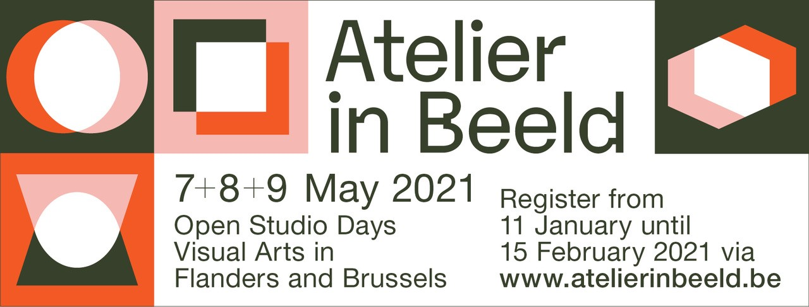

Application form for Individual artist with own studio

Intro
You can download this form, fill it in and email it to info@atelierinbeeld.be. Don’t forget to attach the pictures to your email!
This is an application for participation, so not yet a final registration. You will receive a confirmation email when we receive your application. Then we will check it and we will send you another confirmation if your application has been approved.
Please fill in the form as completely as possible. Without a picture of your work and the studio we can’t approve your application. (* = required)

- Contact details*

Please fill in your personal details. We will contact you using this email address.
- First name:
- Last name:
- Email address:
- Confirm email address:
- Phone number:
- Address studio*

Please fill in the address of the studio people can visit for Atelier in Beeld.
- Your studio’s street:
- Your studio’s house number:
- Your studio’s postal code:
- Your studio’s city/town:

- Details studios

- Name studio *:
You participate in your own studio. We advise you to use your own first and last name, so it’s easier to find you on the website. Would you prefer not to be mentioned by name in our communication? Then you can write down a stage name or pseudonym here.

- Opening dates *:
You choose how many and on which days you participate. The only conditions; you participate at least one day and you are present in your studio at the proposed hours.
Please indicate on which day(s) you will participate:

- Friday 7 May (18h – 22h)
- Saturday 8 May (10h – 18h)
- Sunday 9 May (10h – 18h)

- The studio has wheelchair access *:
Please indicate what is applicable
  - Yes
  - No
This means that there are no stairs and no thresholds higher than 2 cm, unless you provide a ramp with a low slope. It also means that the passageways are at least 90 cm wide.

- Picture of your studio*
The photo will be shown on the website. We can only show one picture of your studio, so think carefully about which part you photograph. Show your studio the way it usually looks, it doesn’t have to be neat and tidy. We will also use this photo to approve or reject your application. Important note: make sure there are no people in the photo, not even you.
Only one file.
150 MB limit.
Allowed file types: png gif jpg jpeg.
Please send the picture as an attachment to your email.

- Total surface area of your studio in square meters*:
If your studio is a separate space, you give the total number of m² of this space. For example, if your studio is located in your kitchen, you give the number of m² of the entire room. So you have to estimate the space where people will stand to see your studio. We ask this to prepare for possible Covid-19 measures in May 2021. If necessary, we can determine how many visitors you’re allowed to receive and link a digital reservation system to your participation.

- I want to receive a promo package*:
  - Yess
  - No
We’ll send you a free package with posters (A0 and A2), invitation cards and signposts. Very useful to invite people and make your studio visible in the neighborhood!

- I am committed to participate in Atelier in Beeld in a Covid-19 safe way*
We follow the changing situation closely and keep all participating studios informed. We will support the studios in the precautions that need to be taken (information, sign posting, schedules, reservation system if necessary…).
  - Yess
  - No

- Phone number:

- Email address:
At this phone number and this email address people can reach your studio before and during the open studio weekend. These contact details will be published on your page on the website.

- Website
The link will be published on your page on the website.
This should be an external URL, like http://example.com.

- Details artist*
- First name:
- Last name:
- The artist’s technique(s) : choose technique

- Sculpture
- Collage
- Digital imaging
- Silversmith’s trade
- Epoxy resin
- Film
- Photography
- Glass
- Graphics
- Wood
- Illustration
- Installation art
- Jewelry design
- Calligraphy
- Ceramics
- Mixed media
- Mosaics
- Painting
- Street art
- Comic- and cartoon drawing
- Drawing
- Textiles

- Pictures of the artist’s work*
Send us up to 3 photos of 3 different works in high resolution. The photos will only be shown on the website. Think carefully about which images you pick. Some basic rules: 1) make sure the photos are clear and show your work well 2) only your work is shown on the photo, so no selfies or many other distracting materials around your work 3) choose photos of different works.

- The artist’s phone number:
At this number you can be reached before and during the open studio weekend. The phone number will be published on your page on the website.

- The artist’s Facebook page:
This should be an external URL, like http://example.com.

- The artist’s Instagram page:
This should be an external URL, like http://example.com.

I have read and accept the general terms and conditions.*
--> you can check the general terms and conditions at https://www.atelierinbeeld.be/en/downloads
Please indicate ‘yes’ here
- Yes

