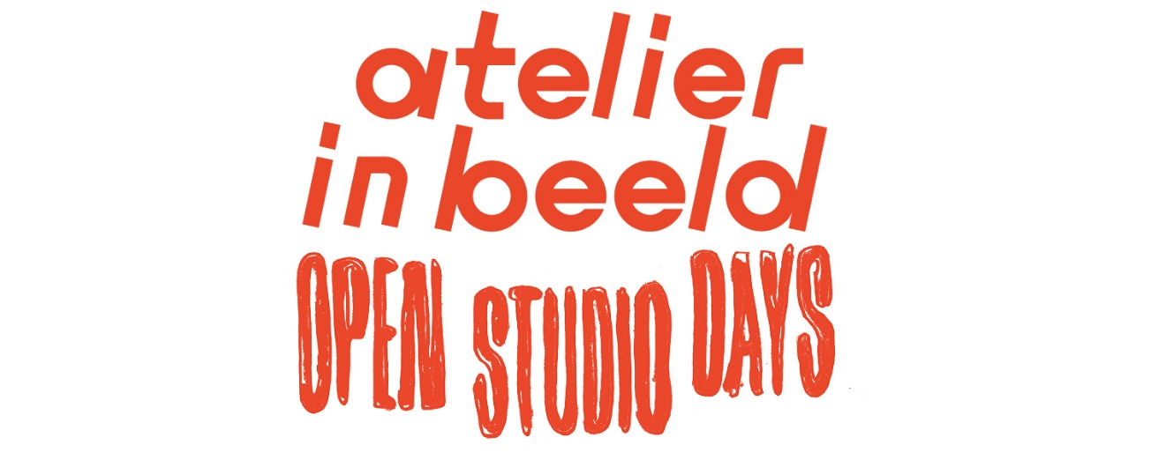***General information during the SIGN UP PHASE (until Feb 6)***

**Show your studio during Atelier in beeld**

Atelier in beeld - open studio days is the big open studio weekend for visual artists all over Flanders and Brussels. A perfect opportunity to show your work or discover studios that weren’t on your radar. Next edition: 6 and 7 May 2023!

Feel like joining in?Registration is free and possible from 9 January to 6 February via atelierinbeeld.be.

**Atelier in beeld is looking for visual artists!**

Atelier in beeld – open studio days is the big open studio weekend for visual artists all over Flanders and Brussels. A perfect opportunity to show your work or discover studios that weren’t on your radar. Next edition: 6 and 7 May 2023!

During the last edition, 2000 visuals artists opened the doors to over 1300 studios. As a visitor to Atelier in beeld you discover new artwork, meet the artists and witness their process up close. As an artist the open studio days are a convenient way of showing a (new) audience your work and your work environment.

All visual artists aged 18 and older with a studio in Flanders or Brussels can participate in Atelier in beeld. Beginners and experts, professionals and non-professionals, young and old. Some artists work in a big warehouse, others in a vacant building, in a separate room at home, or simply at the kitchen table. It doesn’t matter, as long as it's your fixed working space!

Individual studios, group studios, collective studios, art academies' studios, organisations or health care institutions that organise studio activities... all can participate.

Feel like joining in?Registration is free and possible from 9 January to 6 February via atelierinbeeld.be.

---

***General text AUDIENCE PHASE (from 7 February onwards)***

Atelier in beeld – open studio days is the big open studio weekend for visual artists all over Flanders and Brussels. A perfect opportunity to discover studios that weren’t on your radar. Next edition: 6 and 7 May 2023!

Discover work by artists from different disciplines, from sculpture to graphics, from ceramics to textile design. You will get a unique glimpse into their studios and working processes.

Plan your route along open studios nearby on atelierinbeeld.be.

**Discover artists in your neighbourhood during Atelier in beeld**

From painting to graphics, 3D printing to ceramics: be amazed by visual artists in your neighbourhood on 6 and 7 May. Plan your route along open studios throughout Flanders and Brussels on atelierinbeeld.be.

**Discover artists’ studios nearby**

Visit visual artists all over Flanders and Brussels on 6 and 7 May. Plan your route along artists' studios in your neighbourhood on www.atelierinbeeld.be.